NETWORKS FINAL EXAM QUESTIONS
1. Explain in detail the following mechanisms: aggregation, fragmentation, modulation, attenuation, amplification and encapsulation

a) Aggregation:
Link aggregation is the combining of multiple network connections in parallel by any method in order to increase throughput (amount of materials passing through the system) and to provide redundancy in case one link goes down.
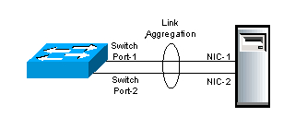

b) Fragmentation:
In the layered Network Architecture, a Service Data Unit (SDU) received from a Layer N+1 through the Layer N/N+1 interface has to split into smaller pieces, due to the size limit in Layer N, where each SDU acts as an individual SDU.
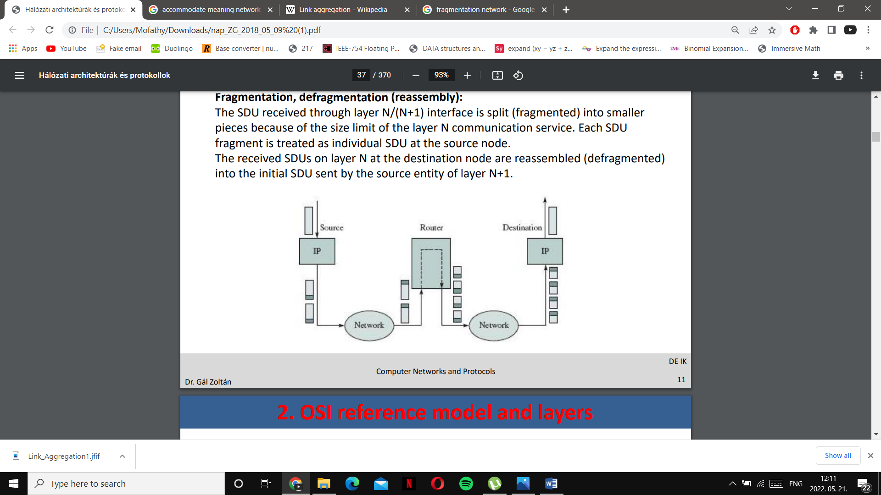

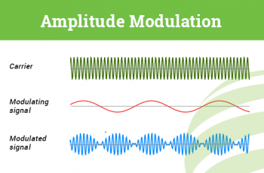
C) Modulation: The process of converting data into radio waves by adding information to the Analogue carrier signal, where data transfer channel can be represented as a frequency band, then the digital data is mapped to the analog carrier signal. The amplitude of the analogue carrier signal would then be modified in function of data to become a modulated signal

D) Attenuation: Loss of signal strength in Networking cables or connections.
The attenuation depends on the frequency, as the frequency increases, the attenuation also increases. Passive or active repeaters are used in higher distances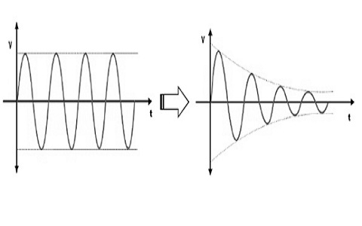
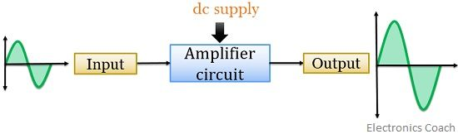
E) Amplification: Boosting the signal in the optical fiber so that it overcomes attenuation. The distance is increased when the data between two sites can be transmitted.

F) Encapsulation: In the layered network architecture, the signal data unit received by a Layer N through the Layer N/N+1 interface is collected with the header and the eventual tail fields obeying the Layer N rules.
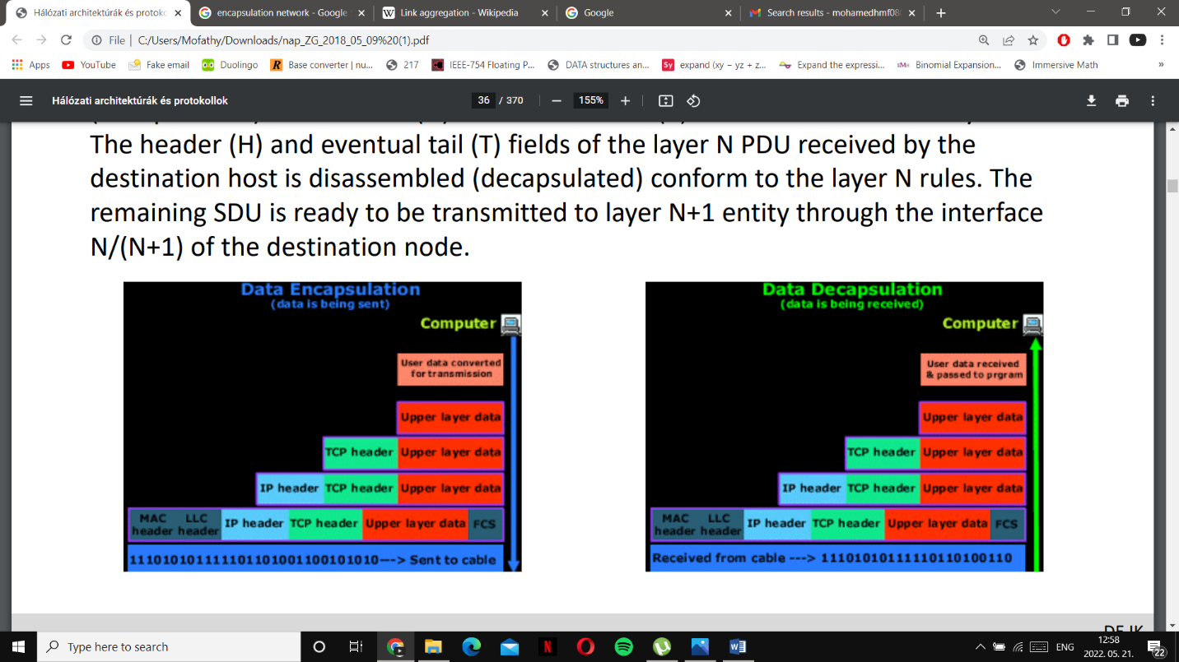

2.Explain in detail the elements and mechanism of the general communication functions
Layer N: Set of communication rules belonging to the logical Layer N
Layer N/N+1 Interface: Common border between Layer N and Layer N+1 on the same communication node, where Data messages are transferred from Layer N+1 to Layer N through that interface
Protocol: An established set of rules that determine how data is transmitted between different types of devices.
Peer entity: Communication entities of the 2 communication nodes that belong to the same communication layer.
Protocol Data Unit(PDU): Message transmitted by the peer entity with the layer protocol.
Service Data Unit (SDU) : The content transmitted through the Layer interface to the next layer in the same node.
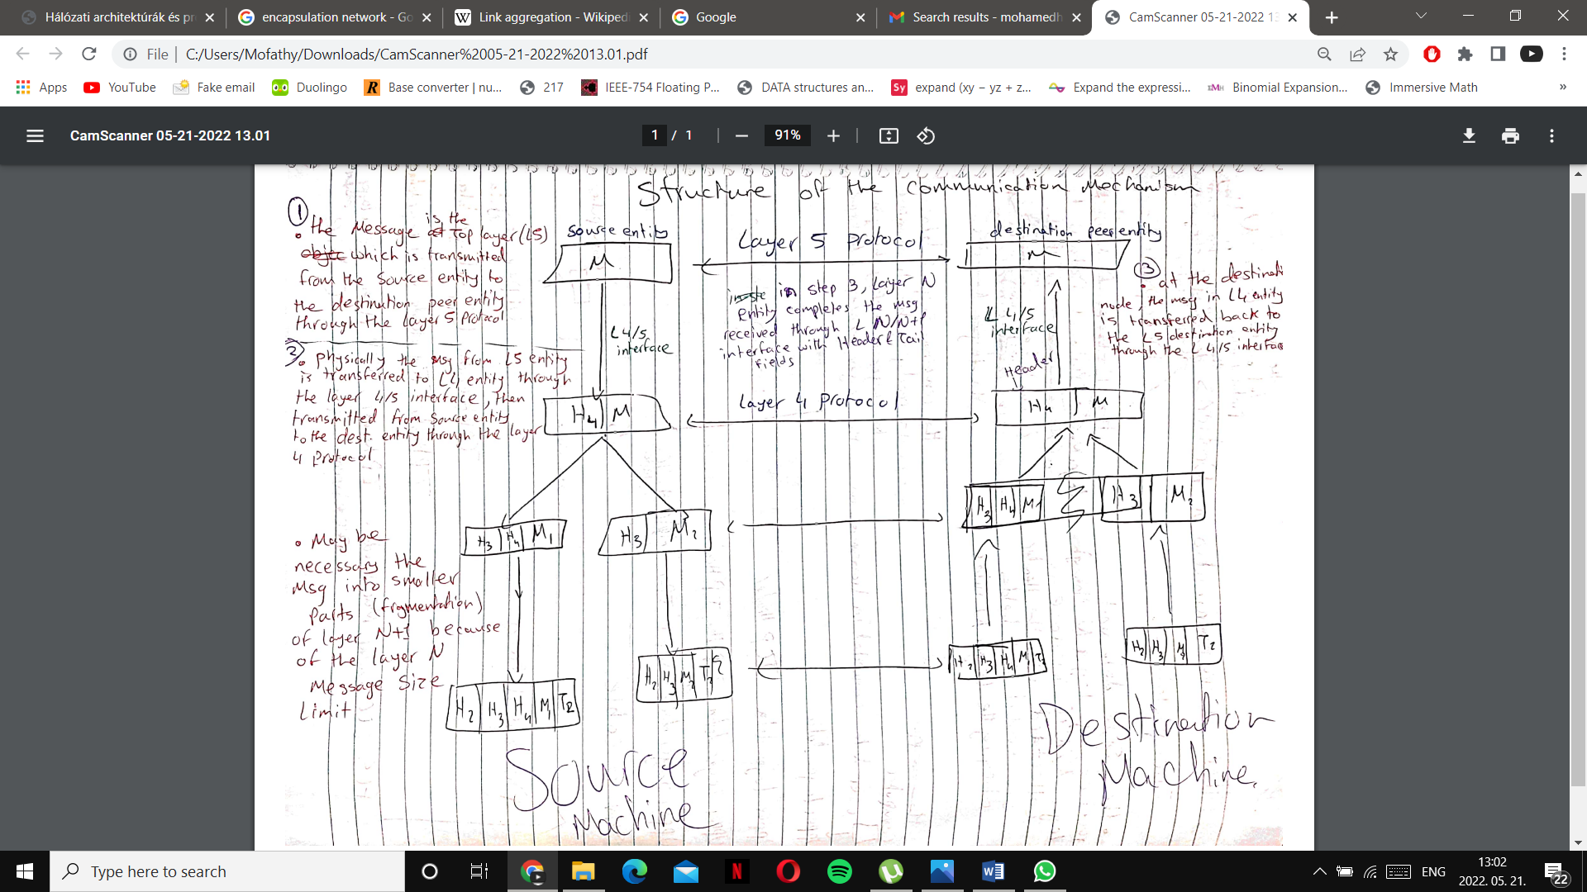

3. Explain in detail the medium access and control mechanism of the IEEE 802.3 technology

4.Describe the intermediate node types and their service production in the three lower level layers of the communication architecture
Network | Router
Data Link | Bridge, switch
Physical | repeater, HUB
0

Repeater/HUB:
HUB: A node that broadcasts data to all computers connected to it
2 types:
Active HUB (Transfers data on media: reamplfication, resynchronization), PASSIVE HUB (analogue amplifier)
REPEATER: Connects segments of a LAN, a repeater is a generator (not an amplifier) and it only forwards data (no filtering is occurred)
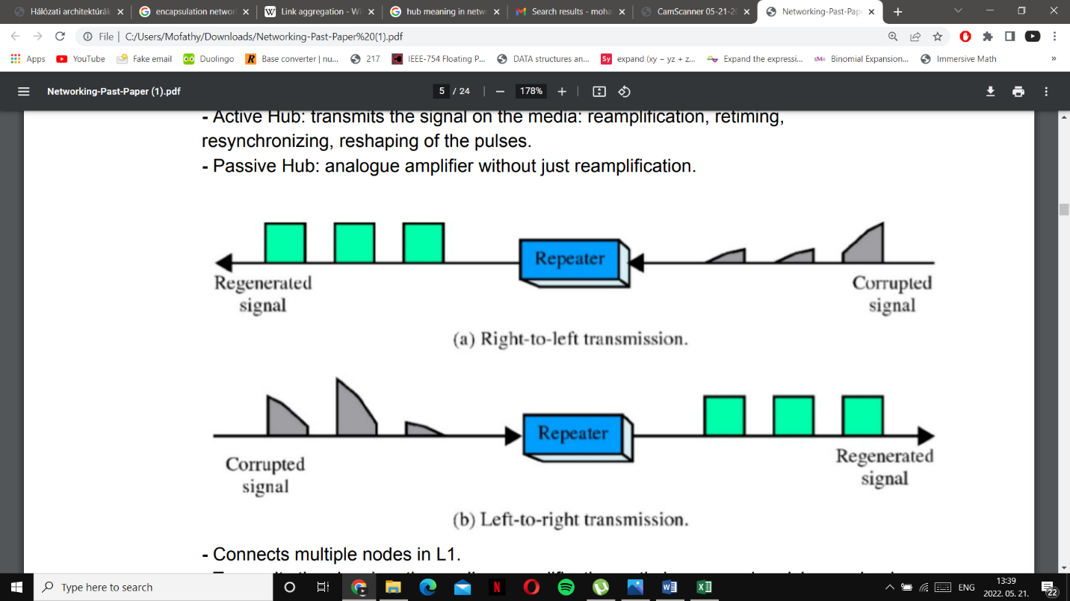

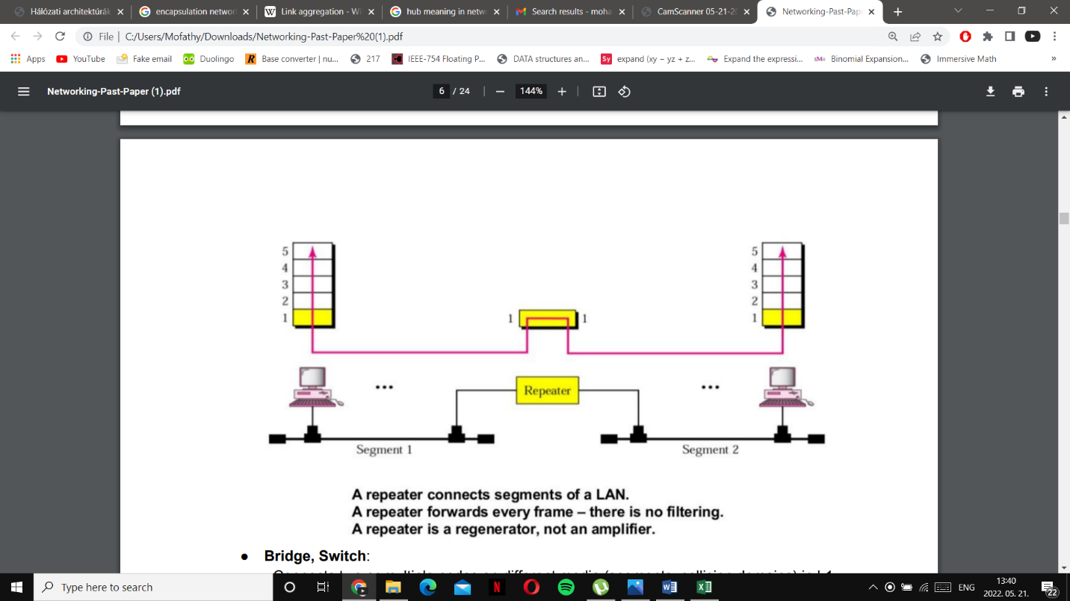

BRIDGE/SWITCH:
Connects 2 or multiple nodes on different media in L1 and L2
Learns the source of the physical address and only transmits the frame to the corresponding destination node

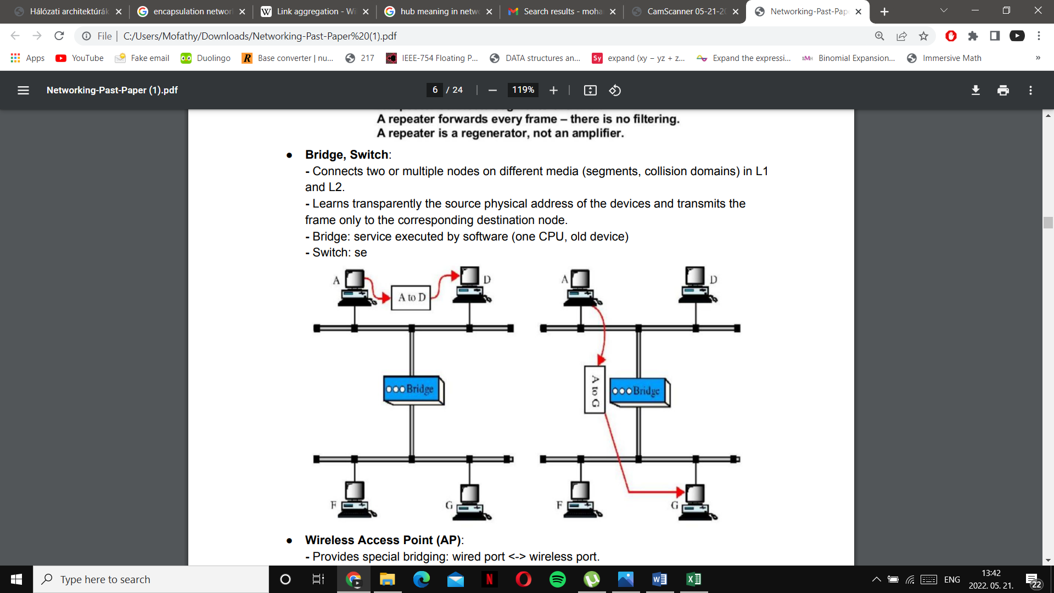

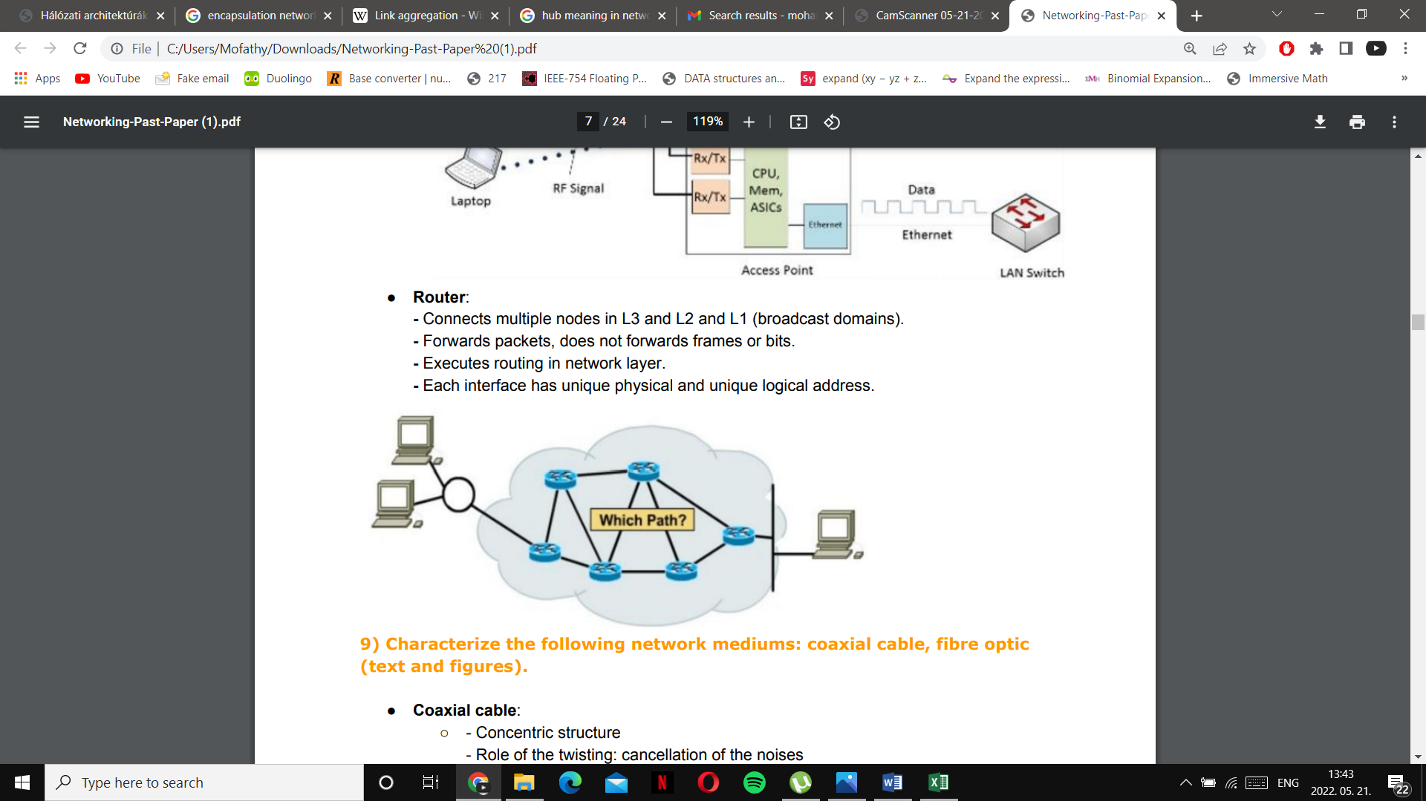
5. Compare and explain the versions of the ALOHA communication mechanism and prove the efficiency ratio between the variants

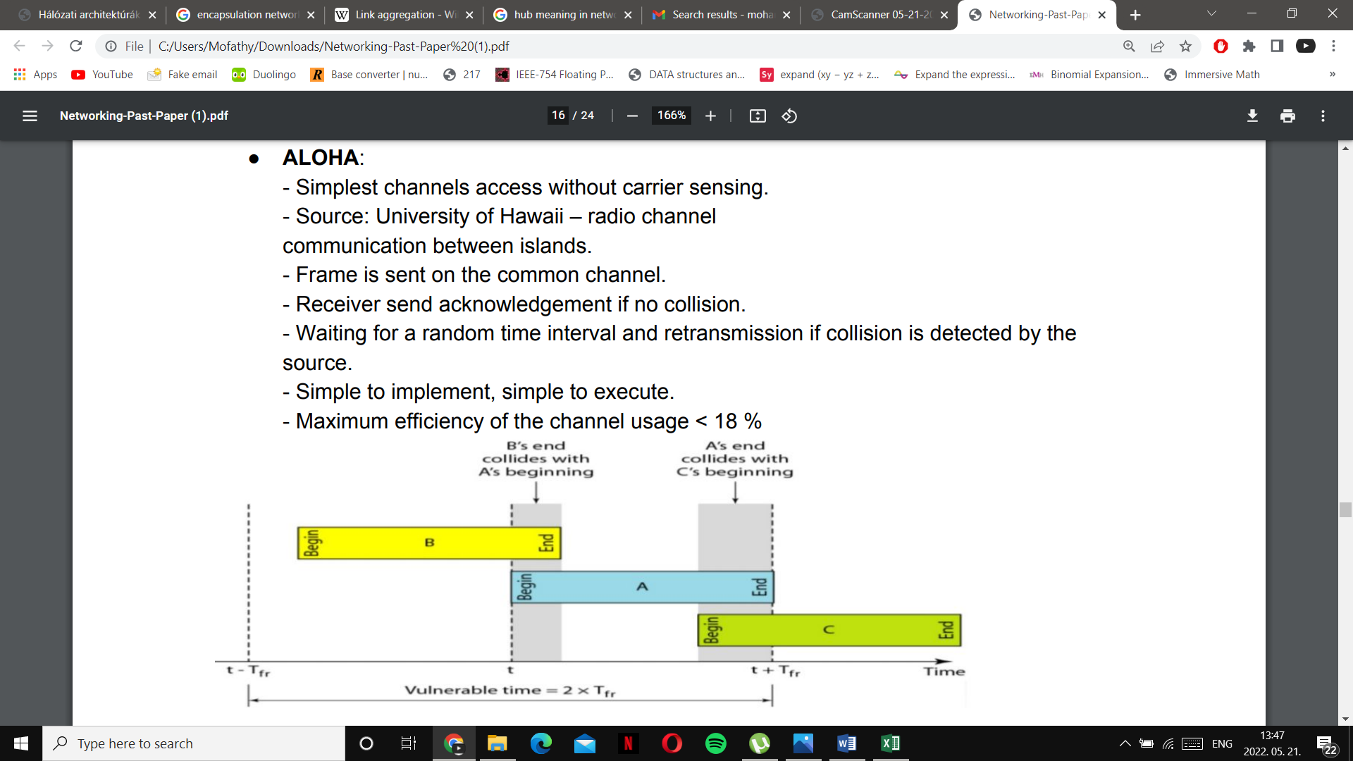

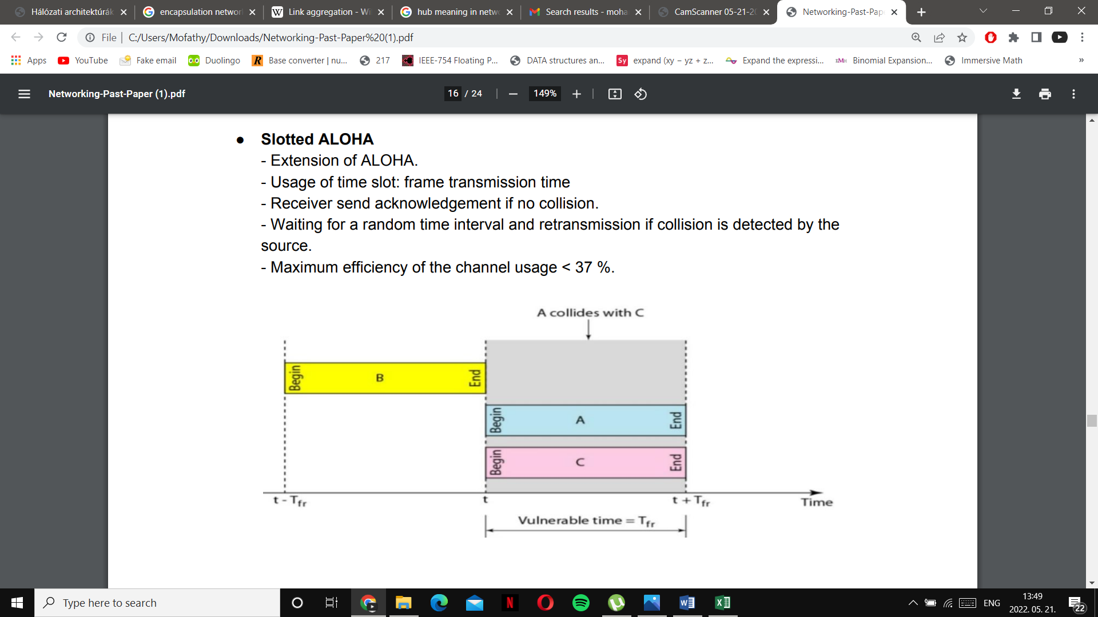

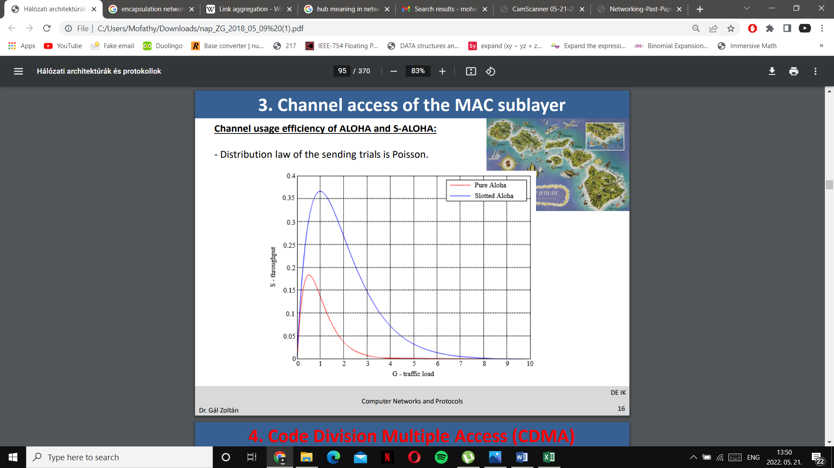
6. Classify and list elements of the routing protocol types used in the Internet
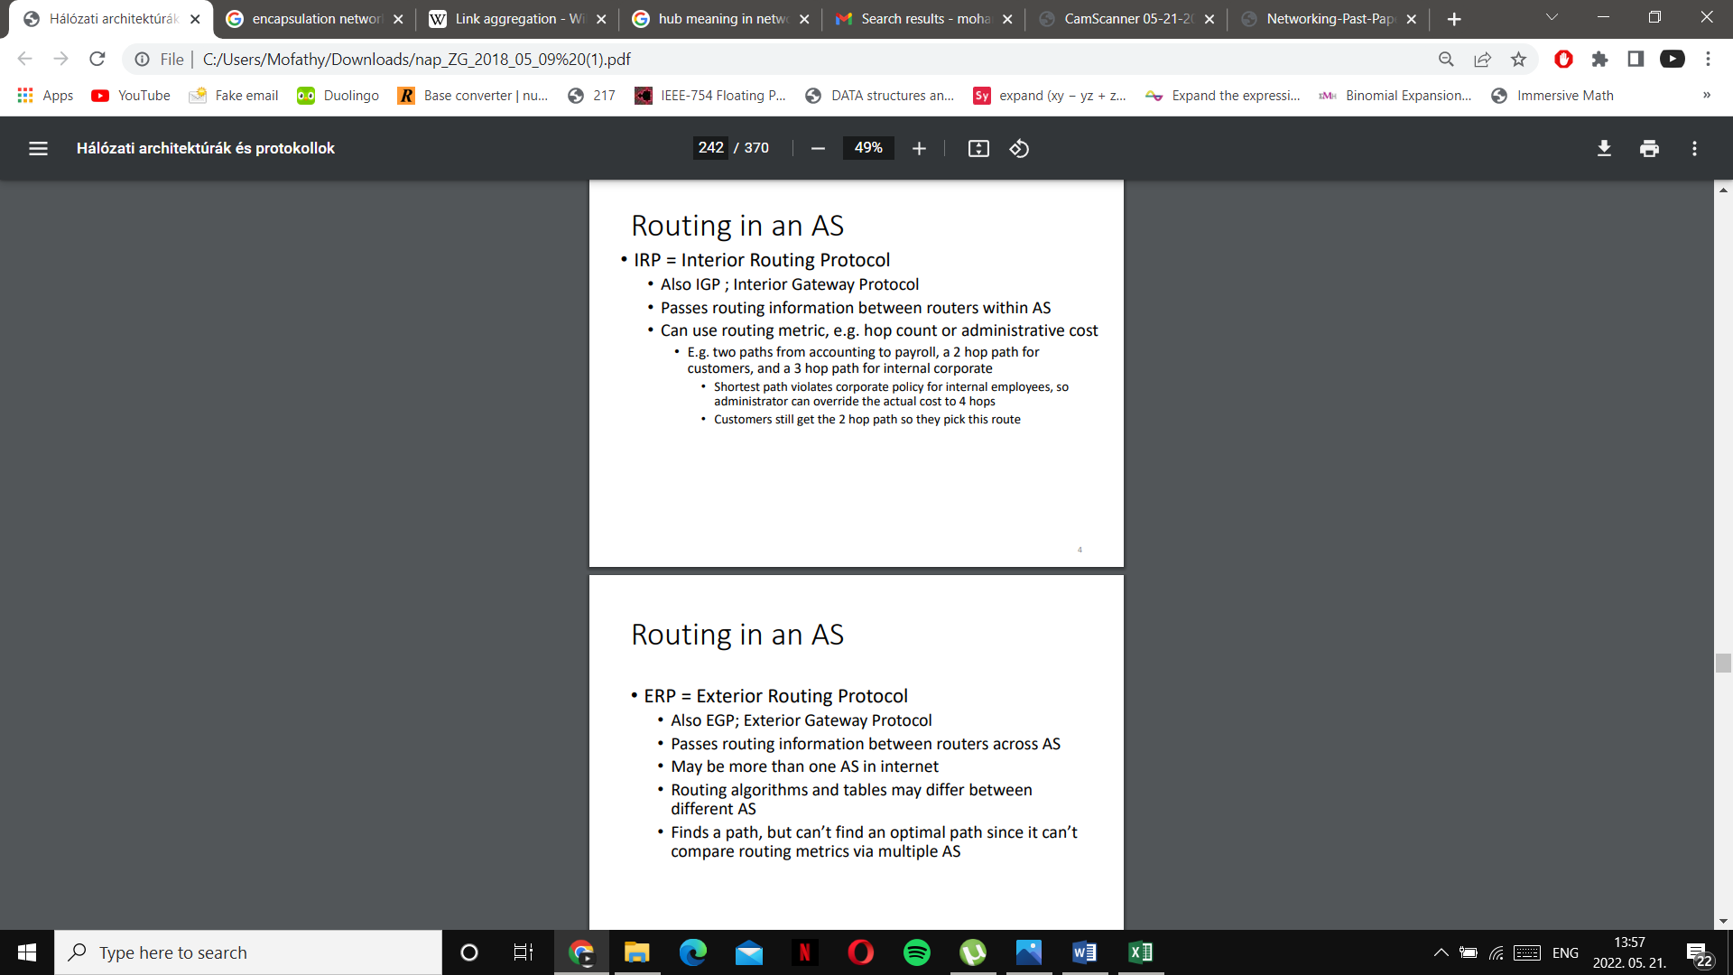

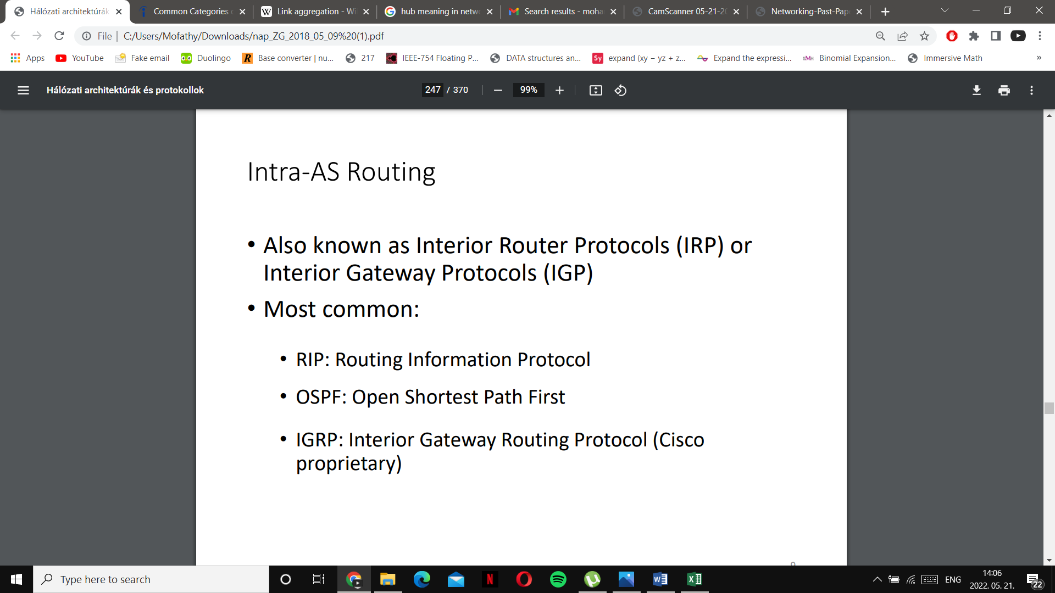
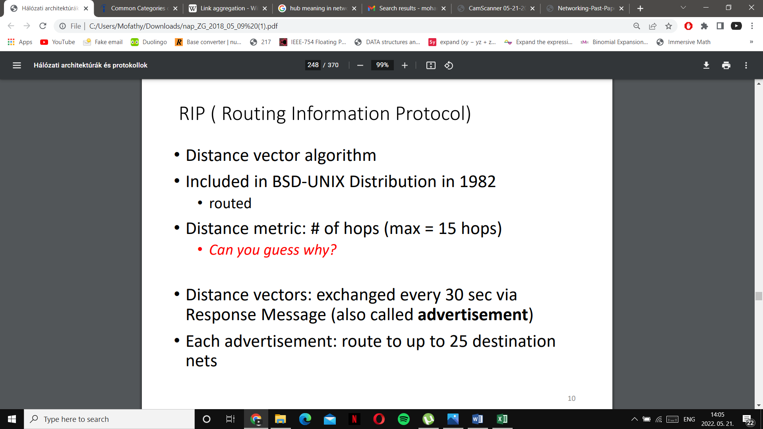

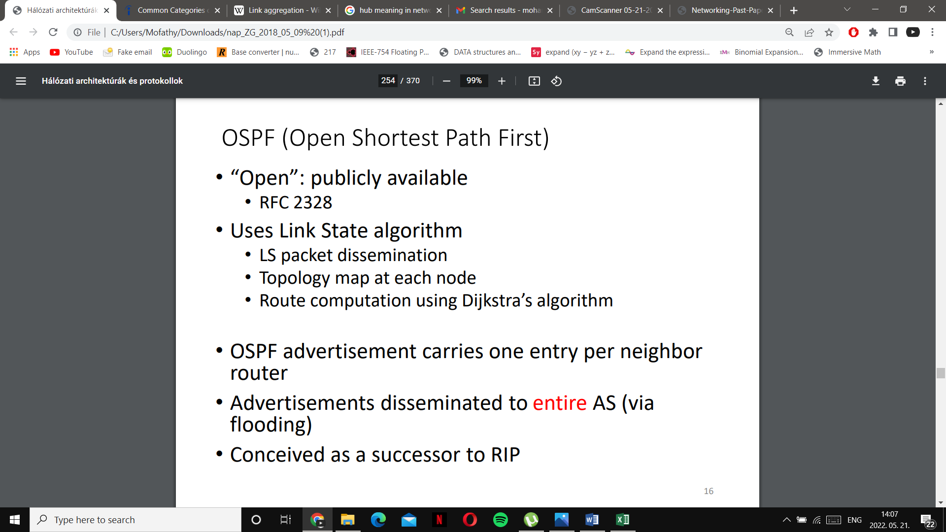

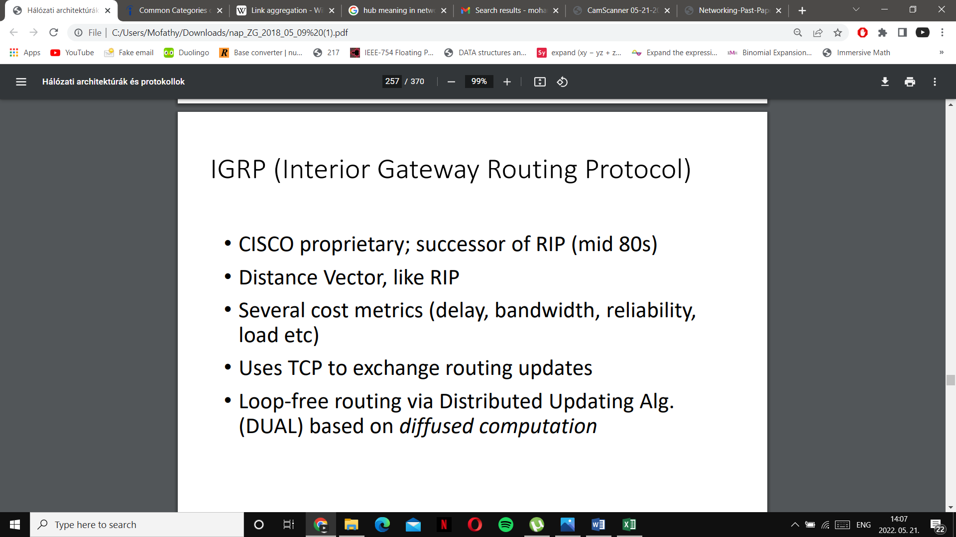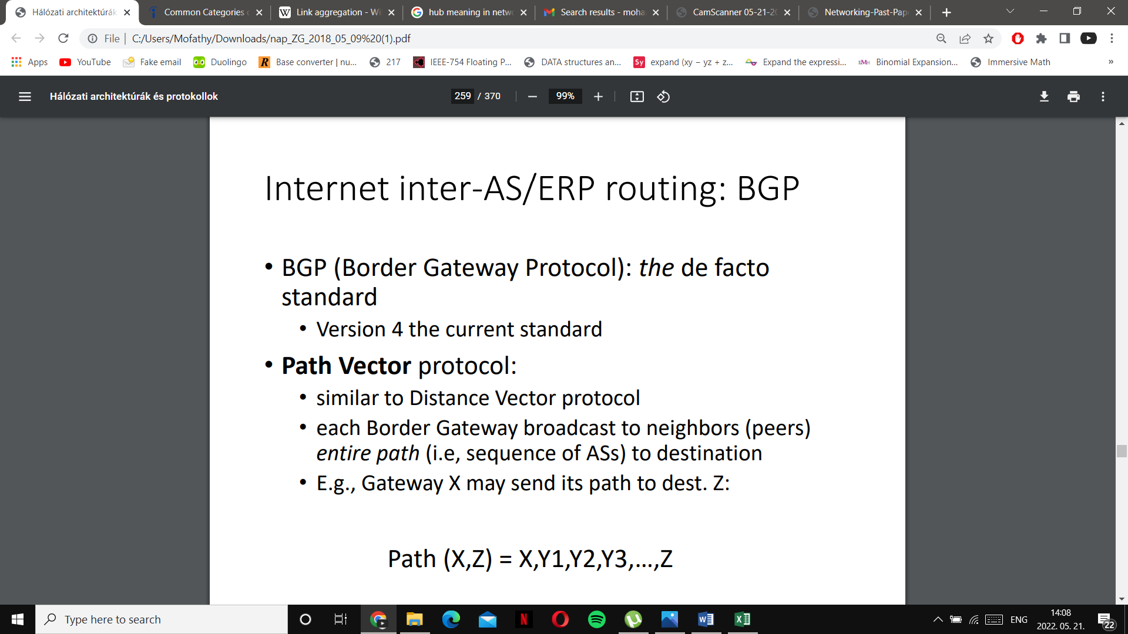
7.Explain the protocol data unit of the UDP

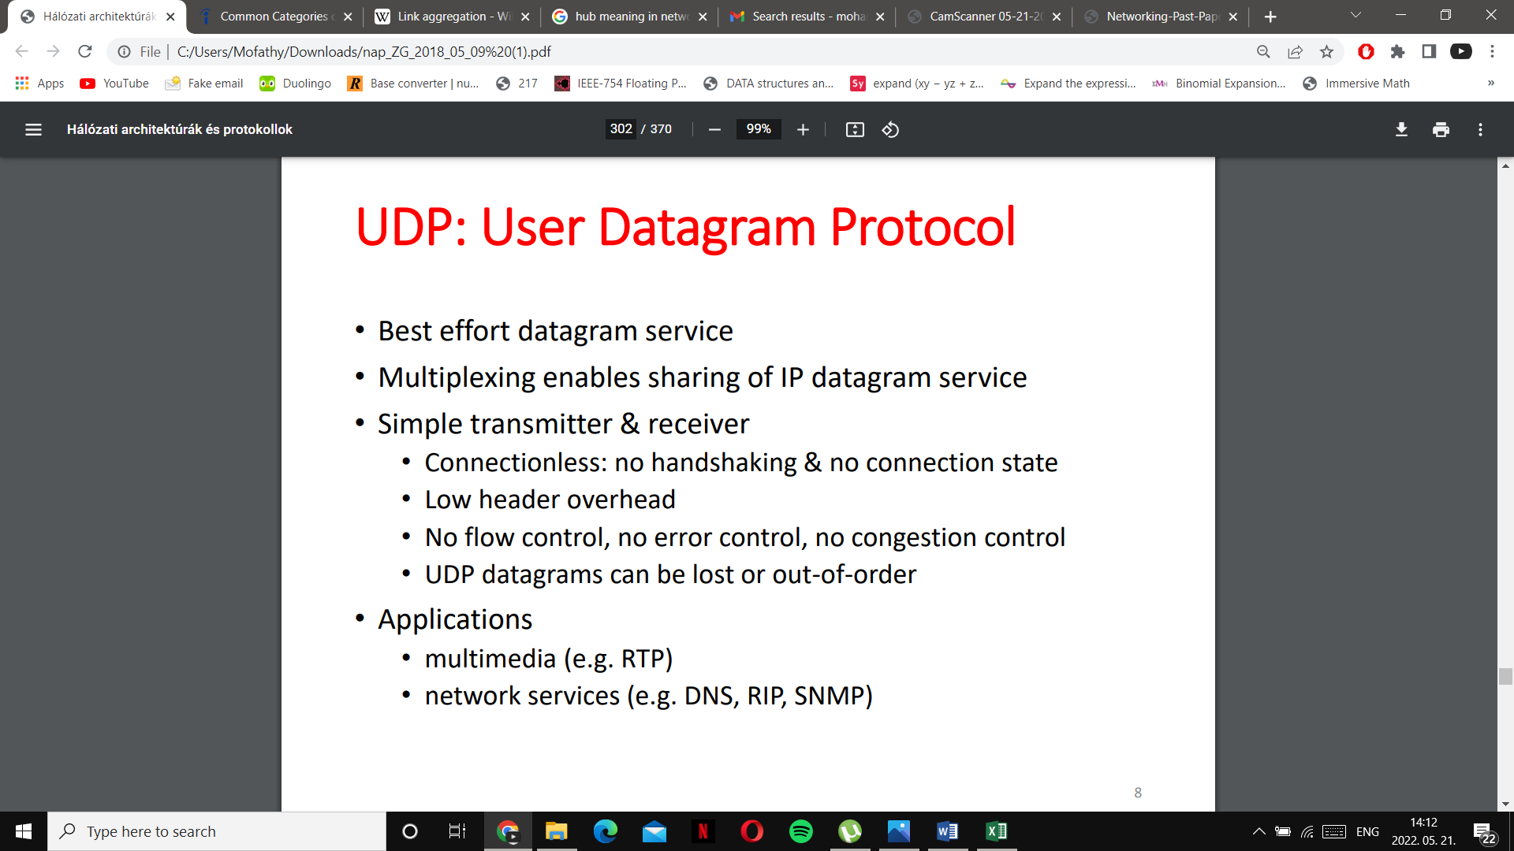

8.Give five application layer protocols and explain the essence of the service provided

